**Q1: Write a program in python to find out LCM of two numbers**

**PROGRAM**

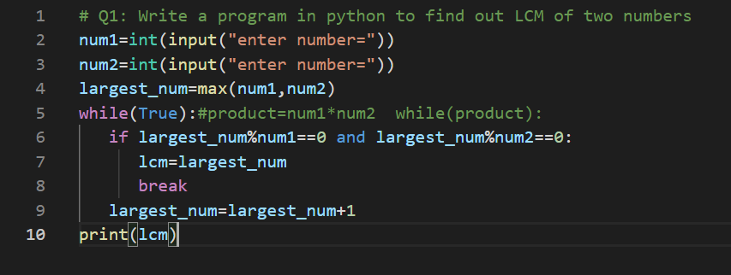

**OUTPUT**

**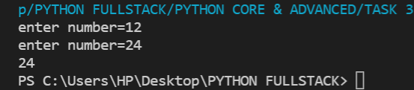  
  
Q2: Write a program in python to find out the factorial of the number  
PROGRAM**

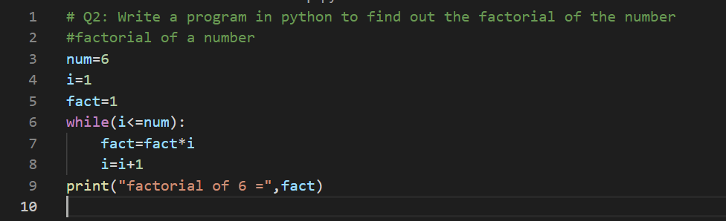

**OUTPUT**

**  
Q3: Write a program in python to find out the HCF of two number  
PROGRAM**

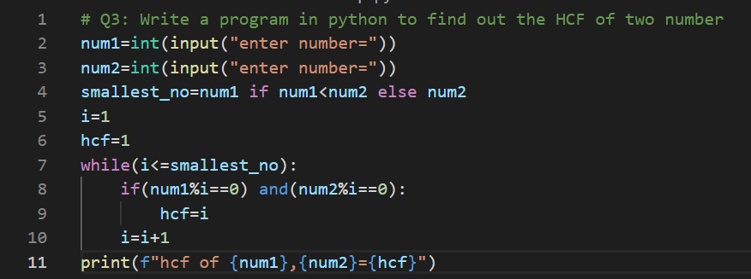

**OUTPUT**

**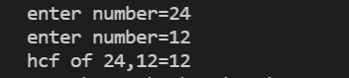  
Q4: Calculate the sum of numbers from 1 to 10 using a for loop :  
PROGRAM**

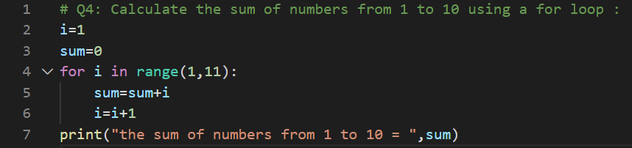

**OUTPUT  
  
Q5: Print numbers from 1 to 5, expect 3 using a for loop**

**PROGRAM**

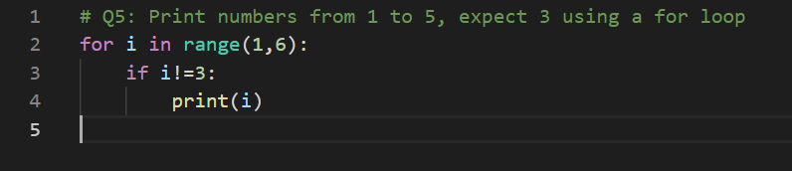

**OUTPUT  
